LAB 1

TITLE: Design of ER Models for Library System and Online Store

OBJECTIVE: To design Entity Relationship (ER) models for the given systems:

Library System

Online Store

THEORY:
An Entity Relationship (ER) Model is a conceptual representation of the data requirements and structure of a system. It is widely used in database design to visually describe the entities involved in a system, their attributes, and the relationships between them.

Key components of an ER Model:

- Entities: Objects or concepts about which data is stored. Entities can be strong (having a primary key) or weak (dependent on another entity).
- Attributes: Properties or characteristics of an entity. Attributes can be simple, composite, derived, or multivalued.
- Relationships: Associations between entities. They can be one-to-one, one-to-many, or many-to-many.
- Cardinality: Defines the numerical mapping between entities in a relationship.
- Primary Keys: Unique identifiers for each entity instance.

Common symbols used in ER diagrams:
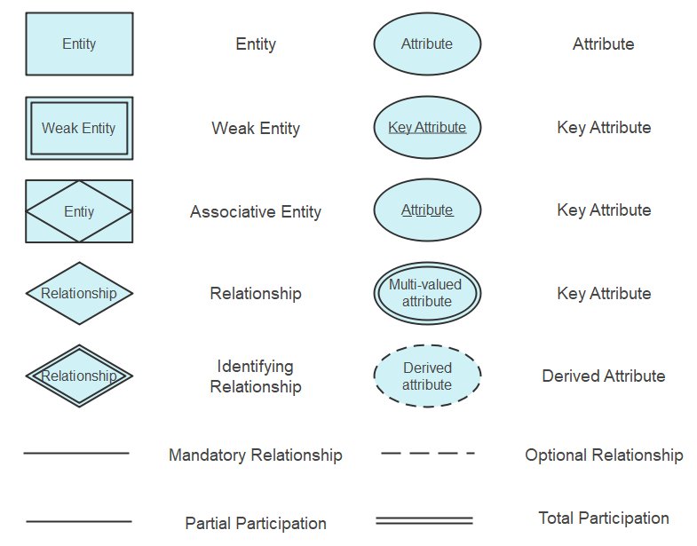

ER DIAGRAMS:

- Library system:

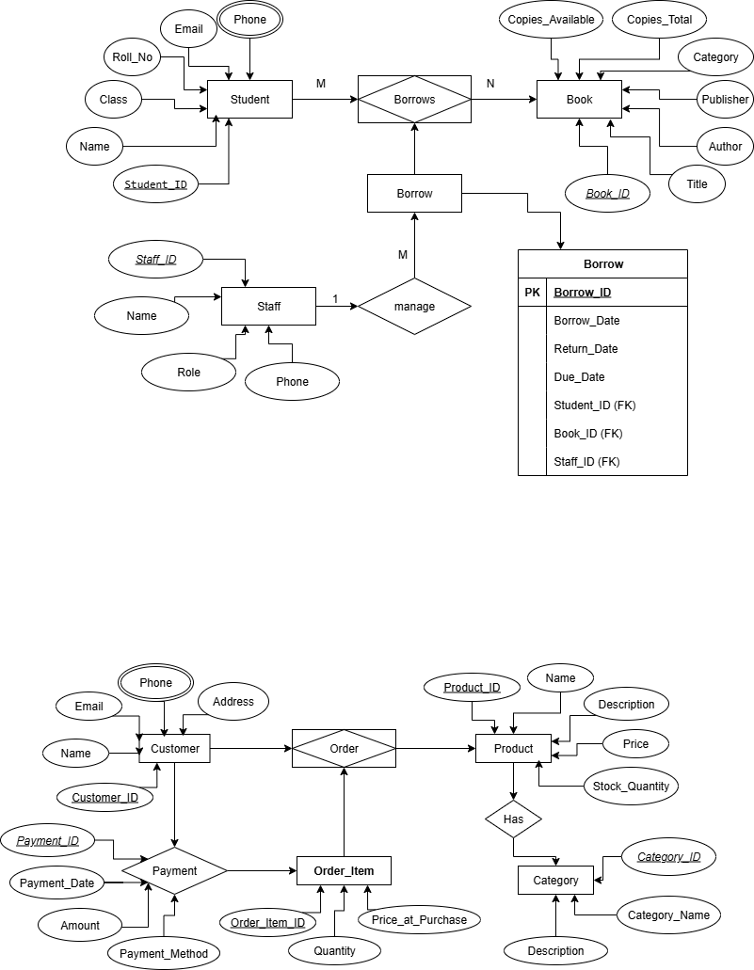

- Online Store:



DESCRIPTION OF MODEL:
- Library System:
The Library System manages the records of books, members, and transactions. Entities include Books, Members, Staff, and Transactions. Relationships define how books are issued, returned, and managed within the library.

- Online Store:
The Online Store system manages products, customers, orders, and payments. Entities include Customers, Products, Orders, and Payments. Relationships capture customer purchases, product availability, and order processing.

CONCLUSION:
The ER models for both the Library System and Online Store successfully represent the data requirements and structure of the systems. This lab provided practical understanding of identifying entities, attributes, and relationships, and designing a clear ER diagram that can be used as a foundation for database implementation.

